UNIT 4.3

COMPUTING PROGRAMMING
TUTOR NAME: MS. IBTISAM MOGUL

SUBMITTED BY FATIMA EJAZ BARRI

1. A) APPLICATION PROGRAMMING INTERFACE DEFINITION
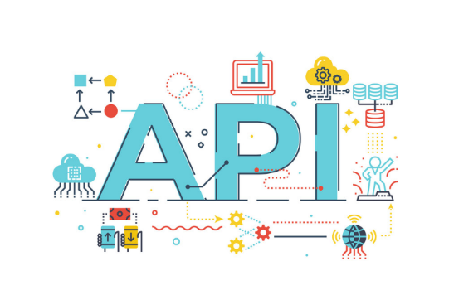
The API is a set of specifications and protocols for application software development and integration. The API is the interface for programming applications. APIs let the product or set interact without having to know how they are integrated with other products and services. This can simplify its development for software, saving both time and money. APIs give you versatility when designing new technologies and products or managing existing ones simplify design, administration and use provide incentives for creativity.

Types of APIs
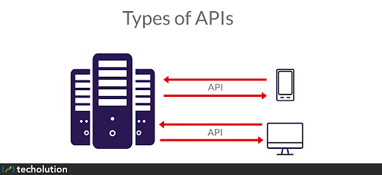
- Operating systems
- Applications
- Websites
Operating systems: the interface between the operating system may be defined by an API. For example, a set of specific APIs that aim to allow the compilation of an application written for a POSIX trying to conform operating system.

API EXAMPLE:
A website that tracks over 15,500 APIs, lists google maps, Facebook, YouTube, flicker and amazon brand ads as some of the most common APIs. There are several examples of popular APIs in the list below:
- Google maps API: google maps APIs allow developers to use a JavaScript or flash interface to embed google maps on web pages. The google maps API is designed for mobile devices and desktop browser applications.
- YouTube APIs: Google’s APIs allows developer to integrate YouTube videos and functionality from YouTube into websites or applications. YouTube APIs include the YouTube analytics API, YouTube data API, live streaming YouTube API, YouTube player APIs and others.
- Flicker APIs: the developer uses the flicker API to access the flicker photo sharing. The flicker API is made up of a set of callable methods and some endpoints of the API.
- Twitter APIs: two APIs are available on twitter. The remaining API allows developers to access core twitter data and the search API provides developers with methods to communicate with information on twitter search and trends.
- Amazon brand advertisement API: the consumer advertising API of amazon provides developers with access to the product range and discovery functionality of amazon to advertise amazon products and monetize a website.
https://www.webopedia.com/TERM/A/API.html
The tuber package for YouTube API
There is tuber package that is designed for YouTube data analysis only.
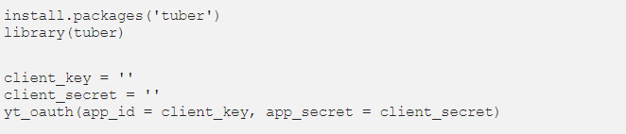
Including the number of videos of a particular channel the number of views likes and comments on a video and so on to call this data. You need to install “tuber” package first then you ask google for the authorization token.
When your comments on this document, a tab will appear with a few numbers that will allow you to approve the request. If you are testing your local device, link to the YouTube API. Some of the features that might be useful to analyse and bundle YouTube data.
Get all channel video stats: this is a channel statistics feature for all videos. To use this, you need a channel ID.
Get video details: it provides more specific information like the video’s publication date. Titles, descriptions, thumbnails and categories are available as well.
Get all comments: it gives you all the video feedback so you have a strong use of text mining on specific topics or channels list channel activities: it returns a channel activity list.
List videos: the most common videos are returned.

ADVANTAGES OF APPLICATION PROMGRAMMING INFTERFACE
- Automation: computers can do the work of APIs rather than humans. The agencies can upgrade workflows though APIs to make them quicker and more efficient.
- Personalization: any individual or organization can customize the content and services they use the most by means of APIs.

1. B) the Software development lifecycle (SDLC)
The software development life cycle SDLC is a process used to develop software systems. The SDLC’s main goal is to develop software that meets and exceeds customer expectations.
The SDLC consists of the following steps to meet their main goal, develop a good software system.
Phase 1: planning
The planning phase consists of determining the main goal of the product and the software system. This phase also consists of planning of how to reach said goals. The two primary activities involved in the planning phase are as follows:
- Identification of the system for development
- Feasibility assessment
Phase 2: analysis
In the process of analysis, the business requirements needed for the completion of the project are analysed and the planning of the project is modified. The two primary activities involved in the analysis phase are as follows:
- Gathering business requirement
- Performing a detailed analysis
Phase 3: design
In the design phase, we plan and confirm the desired features and look of the project. This phase includes business rules, pseudo code, screen layouts and other necessary documentation. The two primary activities involved in the design phase are as follows:
- Design of IT infrastructure
- Designing the system model
To avoid any fail in the system or the final project, the technical bae of the software should be of high quality.
Phase 4: development
In the development phase, all the information from the phases is kept in mind and the developing of the software system is done according to the plan. The two primary activities involved in the development are as follows:
- Development of IT infrastructure
- Development of database and code
In the design phase, only a rough estimation of the final project is made while in the development phase the rough plans are put to work and tweaked to perfection.
Phase 5: testing
In the testing phase, all the parts to develop the final system are integrated. Testers then follow the software-testing life cycle to system for any malfunctions so that they can avoid them in the final software. The two primary activities involved in the testing phase are as follows:
- Writing test cases
- Execution of test cases
Testing is a very important part of the whole cycle because it helps to build a high quality software. Once test cases are done, the tester compares the expected result to the actual result to see the errors in the system and devises plans to fix them. Writing test cases and executing them is a difficult task for organizations but it promises the execution of a great project if done properly.
Phase 6: deployment
In this phase, the software is put out in the world for the clients use. All the components of the system are put out for public use. This phase is also called the delivery phase.
Phase 7: maintenance
In the maintenance phase, important changes are made to fit the system in the client’s expectations, the organization works to improve the system and updates it. This is necessary to enable the software to stay relevant and helpful in the future. The three primary activities involved in the maintenance phase are as follows:
- Support the system users
- System maintenance
- System changes and adjustment

PLANNING
ANALYSIS
DESIGN
DEVELOPMENT
TEXTING
DEPLOYMENT
MAINTENANCE

WATERFALL MODEL WITH DIAGRAM AND ALL THE PHASE
The waterfall model is a model with liner and sequential approach used in system development life. The team waterfall is used for this classical model because it develops systematically from one phase to another in a downward fashion.
Diagram of the waterfall model
Maintenance
Requirements
System Design
Implementation
Integration and Testing
Deployment of System

Phases of the waterfall model
Requirements: in the phase of requirement, the specification of the inputs and outputs and the final product is marked.
System design: in this phase, a design is made for the system. In addition, the code of the system is created in this stage.
Implementation: from the system design, prepared individual units are integrated in the next system and the whole system is made.
Integration and testing: in the phases of integration & testing, the company puts in the use after system has been successfully tested. Testing is done so that the client does not have any problem during the installation of the software. If there are any flaws or errors. Every unit is tested for its functionality. If it’s there are many errors then they will surface at this point in the process.
Deployment of the system: after the setting up of the system and testing, the system is released in the market and is available for customers use.
Maintenance: this step is done after the release of the system, this is done to solve any problems faced by the clients after live use of the system and to update it according to modern upgrades so that the system can be used in the future.

Advantages of the waterfall model

A) Languages constructs

2. B) design

4. A) Testing

API NAME | VERSION | AUTHOR | TESTED BY | TESTING DATE
 | 1.0 | FATIMA EJAZ BARRI | FATIMA EJAZ BARRI

Test cases
Test ID | T200
Module No | T2-EvenODD_Input

https://www.redhat.com/en/topics/api/what-are-application-programming-interfaces
https://techolution.com/types-of-apis/
https://bbvaopen4u.com/en/actualidad/8-advantages-apis-developers

